How to Create Your own Account

Anyone can create a BehrmanHouse.com account. Each person must have his or her own account.
- Go to www.BehrmanHouse.com and click the button at the top of the page.
- Fill out the User Registration form. Fields with an asterisk (*) are required. Check the box to confirm that you agree with the terms and conditions. Then type the characters you see in the word verification box.
- When you are finished, click the Sign Up button.
- After clicking Sign Up, you will be automatically logged in and taken to the My Account page.
- Personalize your account with a photo. Click Edit My Account Info and scroll down to the Upload picture field. Click Browse to select a file; then click the Save button. The photo you select is what other synagogue members will see in member listings and when you post discussions or comments in classes.

How to Join Your Synagogue’s OLC

Teachers must accept an invitation from their Education Director to join the synagogue.
- Log in to your BehrmanHouse.com account and click at the top of the page.
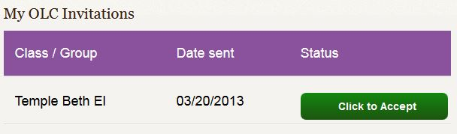
- Click My OLC Invitations in the menu on the left side.
- Click the green Click to Accept button.
- If you do not see an invitation here, make sure your Education Director sent it successfully.

How to Add Students to a Class

Education Directors and Teachers are authorized to add students to OLC classes.
- Any student who has been enrolled in your OLC school can be added to a class at any time.
- Log in to your BehrmanHouse.com account and enter the Online Learning Center.
- From your Dashboard page, find the class to which you want to add students.
- Hover over the blue class box until the green EDIT button appears in the lower right hand corner, then click on it.
- On the Edit Class form you will see the names of students already in the class. Select additional class members from the list provided. You can search quickly for student names using the letters at the top of the list.
  - If you do not find a student’s name on the list, the student has not yet been added to the OLC. Students can be enrolled in the OLC by the Educational Director. A signed permission form is needed for each student.
- Click the green button to save your selections.

Turn over for assessment instructions

How to View Assessment for Learning Software

Education Directors and Teachers can view assessments.
- Log in to your BehrmanHouse.com account and enter the class in the Online Learning Center.
- Find the Learning Software box in the top left corner of the class page.
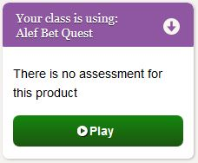 | 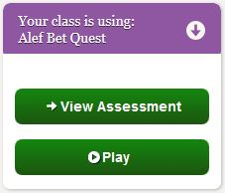
You will see “There is no assessment for this product” until a student completes an activity. | Once students start completing activities, you will see a green View Assessment button.
- Click the button to view the Assessment Report.
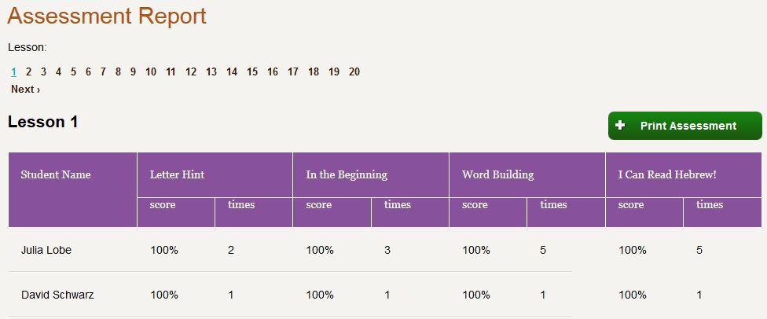
You can select a lesson using the numbers at the top. You will see each student’s score and the number of times they attempted each activity. Only students who have completed the lesson will be listed here.
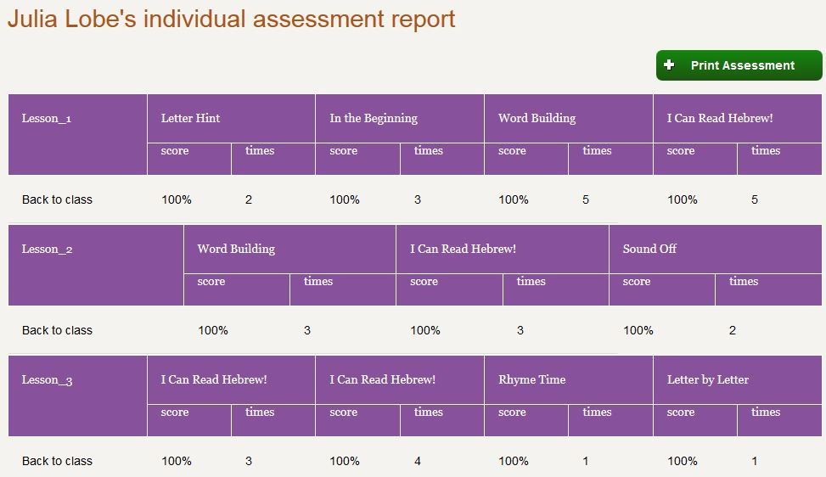
- Click a student’s name to view assessment of his or her completed lessons all on one page.

